WEEK-2: Entity Framework Core 8.0 Guided Hands-On Exercises
Submitted by:
Name: Ankita Adhikary
Regd:2301020444
C.V. Raman Global University Odisha
Lab:1
Here’s a short, note-type version of the lab in simple original wording (easy to write in a practical copy and designed to avoid plagiarism).
You can copy this directly into your notebook.
Lab 1: Understanding ORM with Retail Inventory System
Aim
To learn how ORM works and how Entity Framework Core connects C# classes with SQL Server tables.
1. What is ORM?
ORM (Object Relational Mapping) is a technique that converts C# objects into database tables.
Example:C# Class, Database Table, Product, Category, Categories, Stock, Stocks
Benefits of ORM
- Less SQL writing.
- Faster development.
- Code becomes easier to maintain.
2. EF Core vs EF6
EF Core: Cross-platform, lightweight, faster, supports async queries and modern .NET.
EF6: Works mainly on Windows and is older but stable.
3. Features of EF Core 8.0
- JSON Mapping: Store objects as JSON in SQL Server.
- Compiled Models: Better performance.
- Interceptors: Add logging and validation.
- Bulk Operations: Faster insert, update, and delete.
4. Create Console Application
Commands
dotnet new console -n RetailInventory
cd RetailInventory
5. Install EF Core Packages
Commands
dotnet add package Microsoft.EntityFrameworkCore.SqlServer --version 8.0.11
dotnet add package Microsoft.EntityFrameworkCore.Design --version 8.0.11
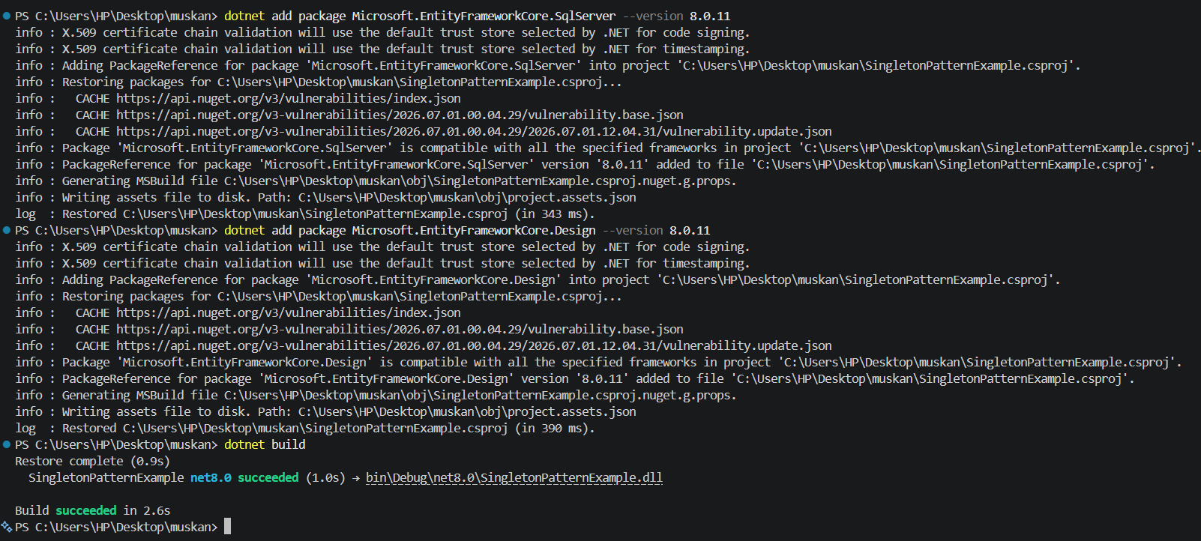

Lab 2: Setting Up the Database Context for a Retail Store
Scenario:
The retail store wants to store product and category data in SQL Server.
Objective:
Configure DbContext and connect to SQL Server.
Steps:
1. Create Models:
public class Category {
public int Id { get; set; }
public string Name { get; set; }
public List Products { get; set; }
}
public class Product {
public int Id { get; set; }
public string Name { get; set; }
public decimal Price { get; set; }
public int CategoryId { get; set; }
public Category Category { get; set; }
}
2. Create AppDbContext:
public class AppDbContext : DbContext {
public DbSet Products { get; set; }
public DbSet Categories { get; set; }
protected override void OnConfiguring(DbContextOptionsBuilder optionsBuild
er) {
optionsBuilder.UseSqlServer("Your_Connection_String_Here");
}
}
3. Add Connection String in appsettings.json (optional for ASP.NET Core).
Answer:
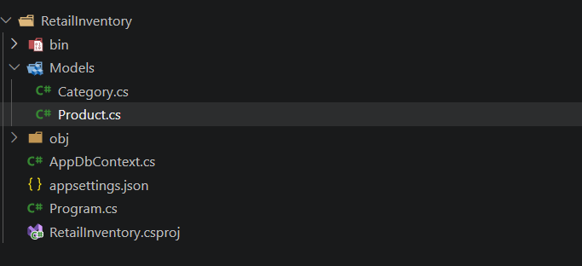
Files structure

paroduct.cs
public class Product
{
public int Id { get; set; }
public string Name { get; set; }
public decimal Price { get; set; }
public int CategoryId { get; set; }
public Category Category { get; set; }
}

catagory.cs
using System.Collections.Generic;

public class Category
{
public int Id { get; set; }
public string Name { get; set; }
public List<Product> Products { get; set; } = new();
}

Output:

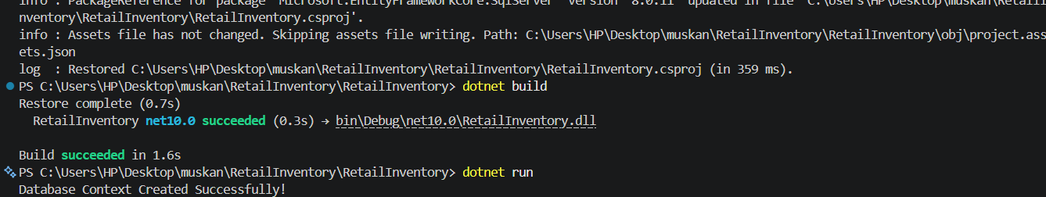
Lab 3: Using EF Core CLI to Create and Apply Migrations
Question
Scenario:
The retail store's database needs to be created based on the models you've defined. You’ll use EF Core CLI to generate and apply migrations.
Objective:
Learn how to use EF Core CLI to manage database schema changes.
Steps:
1. Install EF Core CLI (if not already):
dotnet tool install --global dotnet-ef
2. Create Initial Migration:
dotnet ef migrations add InitialCreate
This generates a Migrations folder with code that represents the schema.
3. Apply Migration to Create Database:
dotnet ef database update
4. Verify in SQL Server:
Open SQL Server Management Studio (SSMS) or Azure Data Studio and confirm that tables Products and Categories are created.

Commands Used
- dotnet tool install --global dotnet-ef
- dotnet ef migrations add InitialCreate
- dotnet ef database update
Solutions: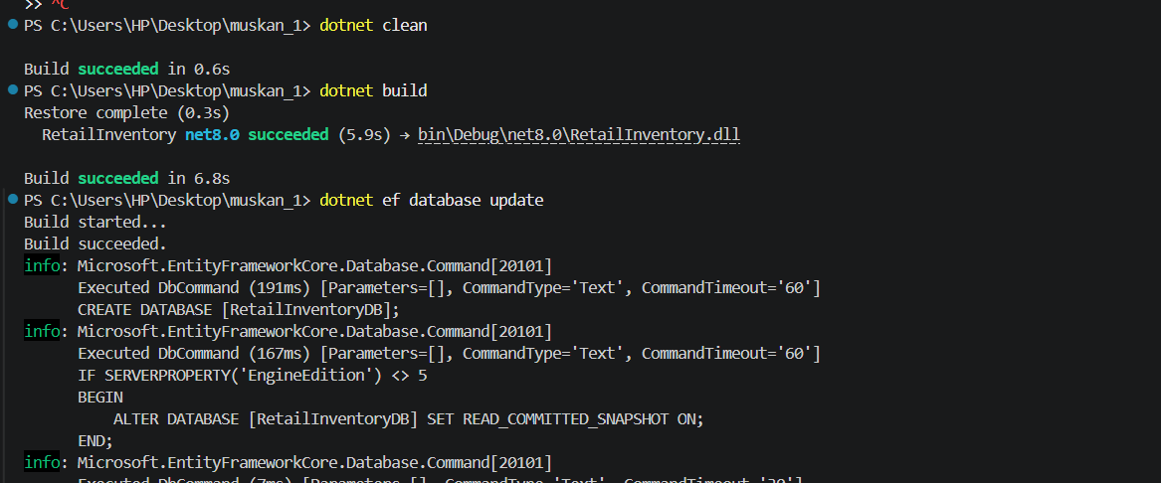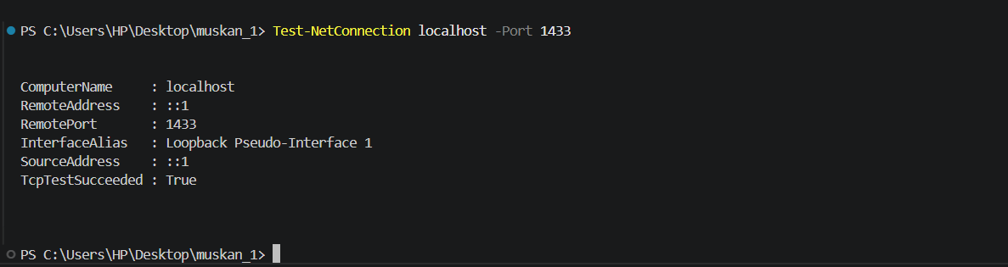

SSMS
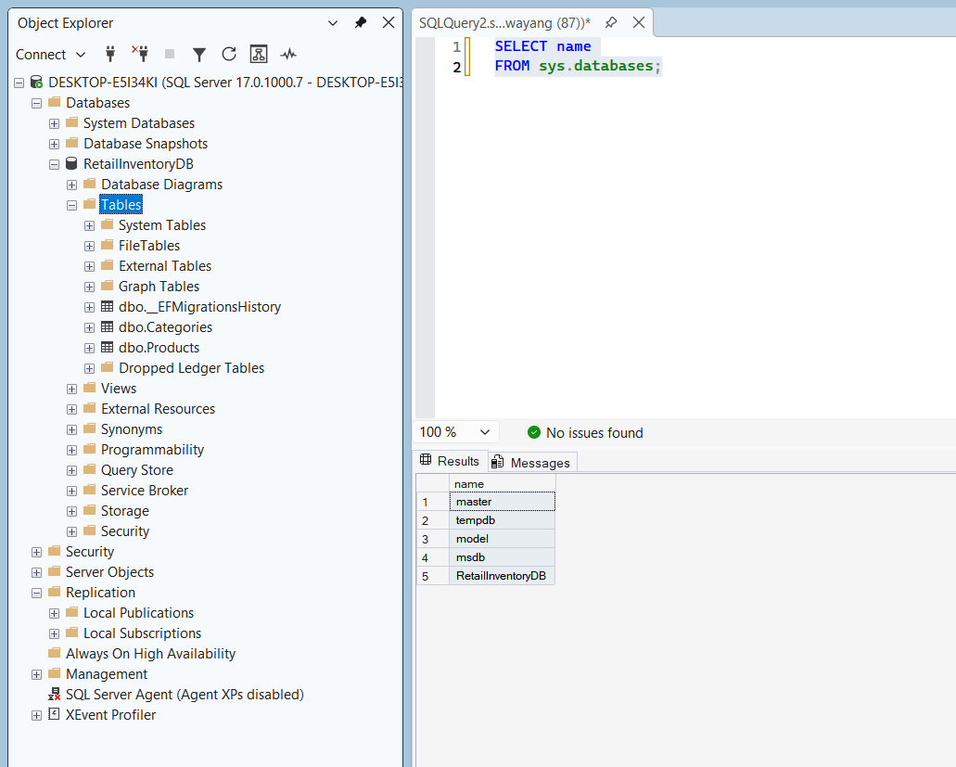

Lab 4: Inserting Initial Data into the Database
Question
Scenario:
The store manager wants to add initial product categories and products to the system.
Objective:
Use EF Core to insert records using AddAsync and SaveChangesAsync.
Steps:
1. Insert Data in Program.cs:
using var context = new AppDbContext();

var electronics = new Category { Name = "Electronics" };
var groceries = new Category { Name = "Groceries" };

await context.Categories.AddRangeAsync(electronics, groceries);

var product1 = new Product
{
Name = "Laptop",
Price = 75000,
Category = electronics
};

var product2 = new Product
{
Name = "Rice Bag",
Price = 1200,
Category = groceries
};

await context.Products.AddRangeAsync(product1, product2);

await context.SaveChangesAsync();
2. Run the App:
dotnet run
3. Verify in SQL Server:
Check that the data is inserted correctly.

________________________________________

using RetailInventory.Data;
using RetailInventory.Models;
using Microsoft.EntityFrameworkCore;

using var context = new AppDbContext();

// Create Categories
var electronics = new Category { Name = "Electronics" };
var groceries = new Category { Name = "Groceries" };

await context.Categories.AddRangeAsync(electronics, groceries);

// Create Products
var product1 = new Product
{
Name = "Laptop",
Price = 75000,
Category = electronics
};

var product2 = new Product
{
Name = "Rice Bag",
Price = 1200,
Category = groceries
};

await context.Products.AddRangeAsync(product1, product2);

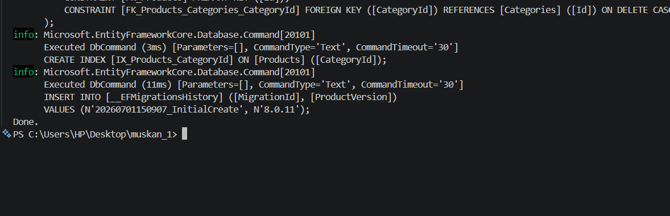
await context.SaveChangesAsync();

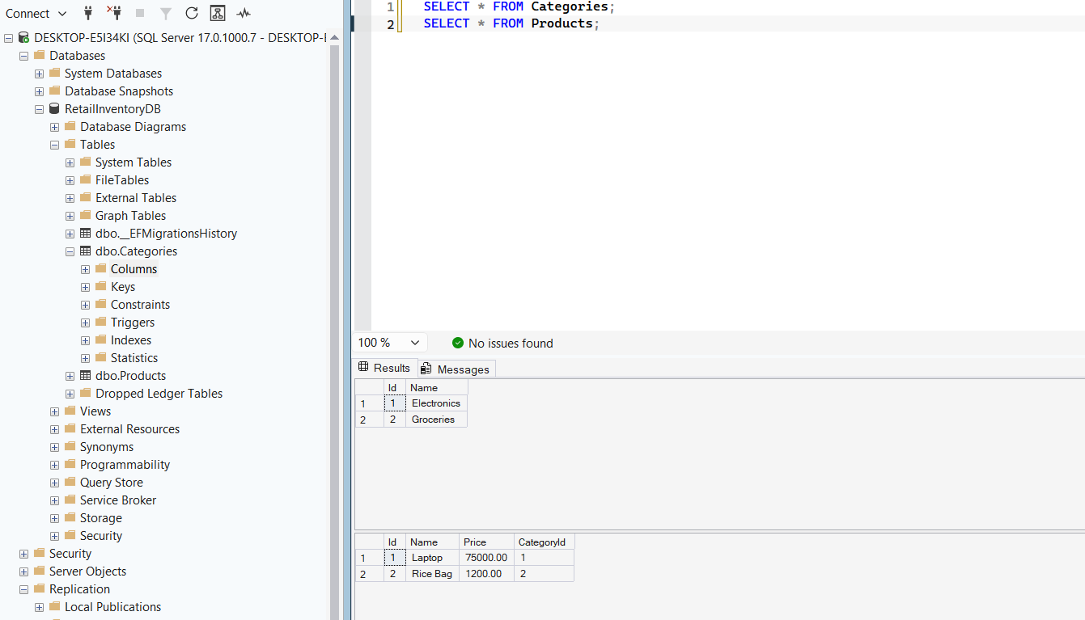
`SSMS

Lab 5: Retrieving Data from the Database
Question
Scenario:
The store wants to display product details on the dashboard.
Objective:
Use Find, FirstOrDefault, and ToListAsync to retrieve data.
Steps:
1. Retrieve All Products:
var products = await context.Products.ToListAsync();
foreach (var p in products)
Console.WriteLine($"{p.Name} - ₹{p.Price}");
2. Find by ID:
var product = await context.Products.FindAsync(1);
Console.WriteLine($"Found: {product?.Name}");
3. FirstOrDefault with Condition:
var expensive = await context.Products.FirstOrDefaultAsync(p => p.Price > 50000);
Console.WriteLine($"Expensive: {expensive?.Name}");

using Microsoft.EntityFrameworkCore;
using RetailInventory.Data;
using var context = new AppDbContext();
Console.WriteLine("===== All Products =====");
var products = await context.Products.ToListAsync();
foreach (var p in products)
{ Console.WriteLine($"{p.Name} - ₹{p.Price}");
}
Console.WriteLine();
var product = await context.Products.FindAsync(1);
Console.WriteLine($"Found : {product?.Name}");
Console.WriteLine();
var expensive = await context.Products
.FirstOrDefaultAsync(p => p.Price > 50000);
Console.WriteLine($"Expensive Product : {expensive?.Name}");
